**Note to Student/Guardian:** We hope you will have fun creating our weekly art lessons. Feel free to **contact your art teacher** with any questions you may have about this lesson. When responding, please include: **Student Name, Grade, Classroom Teacher, Lesson Name.** We would be **happy** to hear from you!

Mr. Jocoy: [ajocoy@nfschools.net](mailto:ajocoy@nfschools.net) Mrs. Melloni: [amelloni@nfschools.net](mailto:amelloni@nfschools.net) Mr. Johnson: [majohnson@nfschools.net](mailto:majohnson@nfschools.net) Ms. Ryan: [tryan@nfschools.net](mailto:tryan@nfschools.net)

Mrs. Brooks: [cbrooks@nfschools.net](mailto:cbrooks@nfschools.net)

**NFCSD Art Educators**

**Grade 2**

***My Favorite Color: Family Portrait***

**Supplies:** crayons, colored pencils, markers, paper

*A **portrait** is a drawing, painting or photograph of a person. I want you to look around your home for portraits of your family. Photographs of the people you love. Look at the photos, who is in it? Where was the photo taken? What else is in the photograph?

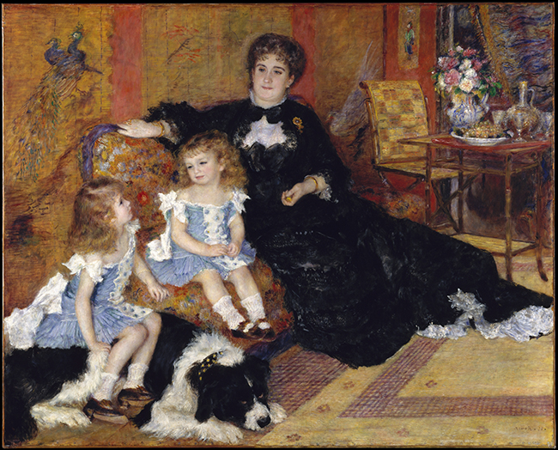

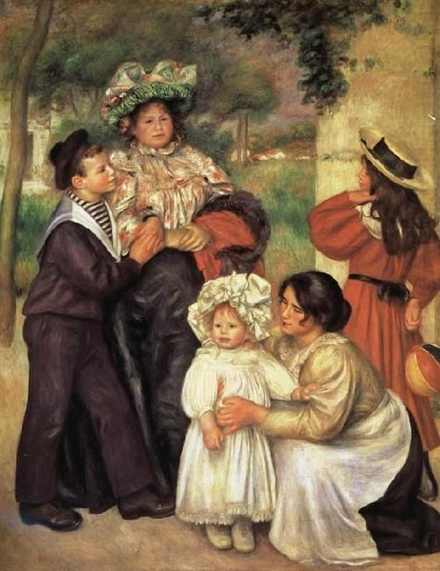

*Artists painted, drew or photographed their families for centuries. I would like you to draw a picture of your family. Please include your family members and pets, if you have them. When you draw your family portrait, add a setting. Are you in front of your home, in your living room, at a park? Make sure you have details. Draw your clothes just how they “look”, with patterns, etc. If someone wears glasses or jewelry, put them in your drawing.

*When you are finished, share your family portrait with your loved ones!